Raneen Othman.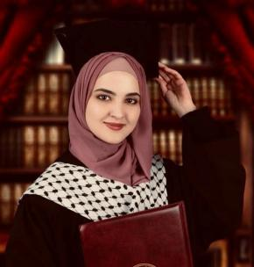

Email: raneen.othman2021@gmail.com

Address : Nablus,Majdal bani Fadel,jawwal tower

Phone: 0592635454

**Work Experience**

Qa and database

Mar 2021 /Jul 2021

ensures that the final product observes the company's quality

standards. In general,these detail-oriernted professionals are responsible

for the development and implementation of inspection activities. the

defection and resolution of problems, and the delivery of satisfactory outcomes.working on database for mobile application.

**Education**

Computer engineering at Najah National University.

I was training as qa for ensuring that products and services meet the

established standards set by the company and a little in mobile application and working with data base.As my first graduation project was mobile application in dart language and flutter as a framework and the second graduation project was a smart home.

**Skills**

.Attention to detail.

.Time management Problem-solving.

. Multitasking.

.Written and verbal-communication.

.Ability to work as part of a learn.

.Knowledge of quality standards.

. Good level in English-language.

.logical thought skills in solving technical

problems.

**Languages**

**LANGUAGES: ARABIC AND ENGLISH.**

**Interests**

As I mentioned I have interest working Ina qa position ,web set and data base.

.